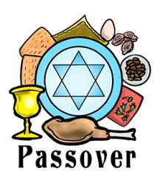

‘ZOOM-ING’ into our CBD Community Seder

We look forward to celebrating the second Seder with you – although sadly not in person. But we will not let any virus keep us apart and will continue to enjoy the readings, songs and traditions of this beloved holiday. Of course, if you’re doing all the cooking and cleaning, it may not be so beloved. And yes, this night will surely be different from all other (seder) nights.

So that you can choose to fully participate with us, may I suggest that you prepare your Seder table with the following items:

✡ Wine and enough glasses for participants
✡ Extra wine glass for Elijah, in the center of the table
✡ Seder Plate, or any other plate, filled with symbolic foods:
- Hard Boiled Egg
- Roasted Shankbone, or chicken bone
- Karpas -Spring vegetable, i.e. Parsley
- Charoset – mixture of apples & wine & (nuts)
- Maror – prepared or fresh horseradish
✡ Small bowl of salted water
✡ And of course, Matzah, traditionally 3 on a plate or in a special holder

We look forward to our service on Thursday, April 9, at 6:00 PM. Check for directions in how to link to us. In the meantime, may all of you enjoy a blessed holiday.

Chag Sameach!

Rabbi Ethan and Lori Adler

