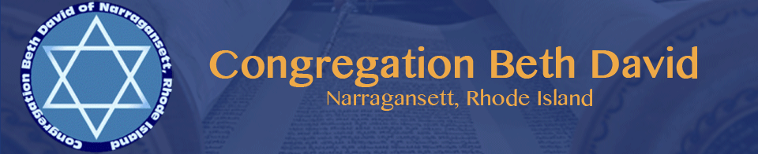

CBD INVITES YOU TO ATTEND A SECOND NIGHT FAMILY PASSOVER SEDER
Tuesday, April 23, 2024 at 6:00 pm at NCC
53 Mumford Rd. Narragansett, RI

JOIN US AS WE CELEBRATE PASSOVER TOGETHER AS A COMMUNITY WITH A SEDER LED BY RABBI ADLER
Enjoy delicious food – Sing “Dayenu”- Drink four cups of wine – Matzo!
Space is limited; do not delay making your reservations.

PLEASE MAIL CHECK (PAYABLE TO CONGREGATION BETH DAVID) & RESERVATION FORM TO:
CONGREGATION BETH DAVID, P.O. BOX 3299, NARRAGANSETT, RI 02882
PAID RESERVATIONS MUST BE RECEIVED BY SUNDAY April 14, 2024
Have questions? Contact Beryl Chapman, ecbc28@gmail.com or 617-775-6264

********************************************************************************************

Name(s) of attendee(s):

 | Adult Members | $45 per person
 | Adult Non-Members | $50 per person
 | Children under 13 | Free
 | Vegetarian Option (Baked Eggplant)

